There is an integer array arr[n] and an integer value d. The array is indexed from 1 to n.

Complete the 'getTripletCount' function below.
Count the number of distinct triplets ( j. k) such that 0< < < < < sn and the sum (a[] + a[] + a[k] is
divisible by d.

Example

a = [3, 3, 4, 7,8]
d = 5
The following triplets are divisible by d = 5. Following are the triplets whose sum is divisible by d (1-based indexing):
· indices (1. 2, 3), sum = 3+3+4 = 10
· indices (1, 3, 5), sum = 3+4+8 = 15
· indices (2, 3, 4), sum = 3+4+8 = 15

Since there is no other triplet divisible by d = 5, return 3.

Function Description
Complete the function get TripletCount in the editor below.

getTripletCount has the following parameters:
int a[n]: an array of integers
int d: an integer

Returns
int the number of distinct triplets

******************************************************
Merge Magic

In a game, there is an array of cells, each with an integer value. In one move, merge any two cells to obtain a new cell that contains the sum of the two
cells. The power needed in each move is the sum of the values of the two merged cells. The goal is to merge the cells until only one cell remains. Find the
minimum possible power required to do so.

Example

cells = [20, 30, 40]
1. Select cells with values 20 and 30 and merge them to obtain [50, 40]. The power needed for this move is 20+30=50

2. Select cells with values 50 and 40 and merge them to obtain [90]. The power needed for this move is 50+40 = 90

The total power required is 50+90 = 140. This is the minimum possible power.

Function Description

Complete the function minPower in the editor.

minPower has the following parameter :
int cells[n]: the values of each cell

Returns
int: the minimum power required to finish the game.

Sample I1:
3
30 10 20
Sample O:
90

Merge 10 and 20, power needed = 10+20 = 30,

Merge 30 and 30, power needed = 30+30 = 60,

The total Power needed is 30+60=90.

Sample I2:
2
100 1
Sample O2:
101

*************************************
Implement a class FibonacciIterator n,whose constructor takes single argument.n, which represent the number of Fibonacci numbers t generate. The class object should be iterable and should return n Fibonacci numbers.
n =4
fibonacci =FibonacciIterator

for num in fibonacci:
print(num, end=' ')

The above code should output "0 1 1 2".

Function Description

Complete the class Fibonaccilterator in the editor below.

The class takes the following parameter:

int n: the number of Fibonacci numbers to generate

Returns

iterable: an iterable with the first n Fibonacci umbers

Test Case 0:
Sample Input:
5
Sample Output:
0 1 1 2 3

Sample Input:
3
Sample Output:
0 1 1

**********************************

4. JavaScript: Private Variables

Implement a class called MyClass. It should have a private integer variable x, initialized to 0, and expose two methods.
· add(val)- increments the value of x by val
· getX()- returns the current value of x

Note: Variable x should be undefined if accessed directly by an instance of MyClass.

There are n queries of either of 2 types.

. 1 val: Increment the value of the private
variable x of an instance by val.
. 2: Return the value of the private variable x of an instance.
The provided stub code reads inputs,instantiates MyClass as needed, and calls the methods.

For example, start with an instance of MyClass named myclass with the value of x initialized as 0. Calling add(5) increases the value of x by 5,
and getX() returns the current value of x, i.e. 5.

Sample I 0:
3//no of queries
1 5//add(5)
1 6//add(6)
2//getX

Sample O:
11

Explanation
Initially, the value of x is 0.
Query 1 adds 5 to x, x= 5.
Query 2 adds 6 to x, x=11.
Query 3 returns the current value of x.

Sample I1:
4
1 4
2
1 2
2

Sample O:
4
6
*****************************************************
The people in HackerLand, are getting ready for a parade, and the participants are all
mixed up. There should be no instance where a red uniform is immediately to the
left of a blue one.
Given a binary string, 0 denotes a person in red uniform and 1 denotes a person in blue
uniform. The goal is to remove any occurrence of "01" in the binary string.
More formally, at each second, all the substrings "01" in the string s are changed
to "10". This process repeats until no "01 "is present in the string. All the substrings "01"in the current state of s are changed at the same time.

Find the number of seconds it takes for this process to stop.
Example
color = "010111”
Here is a simulation of the process where t denotes the current time.
t=0, color = 010111
t=1, color ="101011"
t=2, color ="110101"
t=3, color ="111010"
t= 4, color ="111100"

Hence this process takes 4 seconds.
Function Description
Complete the function getSwapTime in the editor below.
getSwapTime has the following parameter(s):
string color: a binary string that represents the uniform colors of people
Returns
int: the time to complete the process
Constraints
· 1 s /color| ≤3*105 where /color/ denotes the size of the binary string

Sample I0:
0101
Output
2
An Intern at HackerRank is assigned is finding the optimal middle subsequence.
An optimal middle subsequence is the subsequence chosen[] of length 3 chosen from an array arr, such that chosen[0] <chosen[1]>chosen[2] and that the sum of its elements is the minimum possible.
Given an array, return the sum of the values of the optimal middle subsequence. If there is none, return -1.
Note: A subsequence of an array is obtained by deleting some (possibly 0) elements from the array without changing the order of the remaining elements. For example, [1, 3] is a subsequence of [1, 2,3, 4] while [4, 2] is not.
Example
Consider n = 7, arr = [3, 4, 5, 1, 2, 3, 1].
Then, the subsequence [1, 2, 1] can be chosen as 1 < 2 > 1 and sum
=1+2+1=4, which is minimum possible. Thus, the answer is 4.
Function Description
Complete the function getMinimumSum in the editor below.
getMinimumSum has the following parameter:
int arr[n]: the given array
Returns
long_int: the sum of the elements in the optimal middle
subsequence or -1
Constraints
. 3sns 105
. 1 s arr[i]≤ 109
Sample 0:
7
3 4 2 6 1 1 1
Sample O:
8

********************************************

Implement a Least Frequently Used (LFU) cache data structure of size cacheSize that handles two types of queries, GET and PUT.

· A GET query attempts to retrieve the value of a given key.
If the key is present in the cache, it is returned.
· Otherwise, it returns -1.
· A PUT query updates or inserts a key-value pair into the cache
. When the cache is full, the least frequently used key is removed to accommodate the new key-
value pair.
. If there is a tie in the frequency of keys, then the least recently used key is removed.
Return an array of integers where each ¡th element is the answer for the (th) GET query.

Function Description
Complete the function implementLFU in the editor below implementLFU has the following parameters:
int cacheSize: the size of the cache
string queries[q]: the query strings

Returns
int[]: the answers to the GET queries
Constraints
· 2 ≤ cacheSize ≤ 100
. 1≤q≤105
· Queries contain at least 1 query of type 1
· / queries[i]| ≤ 13
. key and value are made up of digits ('0'-'9') only
· Value of key ≤ 300
· Value of value ≤ 106

Example
Suppose cacheSize = 1, q = 5, queries = ['PUT 1 1", 'PUT 2 2", "GET 1 "]
Only cacheSize = 1 element is stored in the cache.

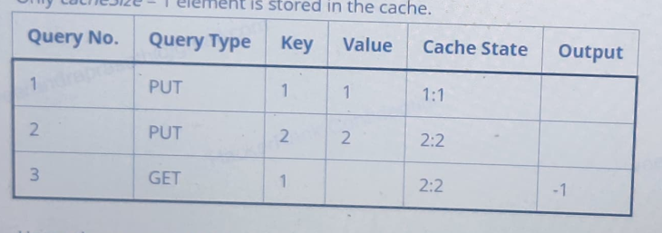
Hence the ans is -1.

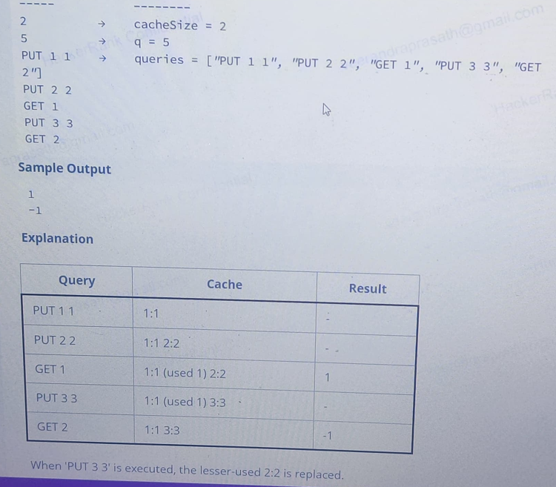

A subsequence is obtained by deleting some (possibly zero) elements of a sequence without changing the order of the remaining elements.
Given an array arr of n non-negative integers, find the smallest non-negative integer that cannot be obtained as the bitwise OR of the elements of some subsequence of the array. The bitwise OR of an empty subsequence is 0.
Example
Let arr - [1, 3]
Output : 2
Explanation :
The subsequences and their bitwise OR values are,
[]-> 0
[1]-> 1
[3]-> 3
[1,3]-> 3
The smallest non-negative integer that cannot be obtained is 2
Function Description
Complete the funcion subsetMEX in the editor below. The function must return the smallest non-negative nteger that can't be dbtailhed as bitwise OR of some subsequence of the array.
subsetMEX has the following parameter(s):
int arr[n]: an array integer

Returns
Smallest non negative integer.

Sample I 0:
1
1
Ou:
2
Explanation:

[]->0
[1]->1

Sample I 1:
2
Arr[2,3]
Ou:
1
Explanation:

[]->0
[2]->2
[3]->3
[2,3]->4

An e-book provider has a list of programming articles, each with a different intellectual value. As an incentive, readers receive awards based on their scores. Readers get points equal to an article's intellectual value for each article they have read twice. Given a list of articles with their page lengths, each article's intellectual value coefficient, and a
limited number of pages that can be read in a day. determine the maximum achievable intellectual value from reading articles during one day
Example
iv = [2, 4, 4, 5]
articles =[2,2.3,4]
p=15
There are n - 4articles – [2,2,3,4] that have a corresponding intellectual values iv - [2, 4, 4, 5].
· p = 15 pages max can be read per day.
. Two best approaches to read the maximum articles are: Read the first, second and third articles (2*articles[0]+2* articles[1]+2* articles[2]=2* 2+2 *2+2*3- 14pages ) or read the third and fourth articles ( 2* articles[2]+ 2* articles[3]=2* 3+2* 4 = 14 pages )
· The maximum total intellectual value is: iv[0]+iv[1]+ iv[2] = 2+ 4 +4=10.

Function Description
Complete the function maximumLearning in the editor below.
maximumLearning has the following parameter(s):
int iv[n]: an array of integers, each article's intellectual value
int articles[n]: an array of integers, each article's page length
int p: number of pages that can be read in one day
Returns:
int: integer value representing the maximum achievable intellectual value in one day of reading
Constraints
. 1<n≤ 103
· 1 ≤ iv[i] ≤ 10°, where 0si<n.
· 1 < articles[i] ≤ 100, where 0 si<n.
. 1 <p≤ 103
Sample 0:
N=3
Iv=[3,2,2]
Articles[] n=3
Articles
3 2 2

P=9

Sample ou:
4
Explanation:

There are n = 3 articles with articles =[3. 2, 2]
pages and corresponding intellectual values iv =
[3,2, 2].
· A maximum of p = 9 pages can be read in a day.
· The best approach is to read the second and
third articles twice: 2* articles[1] +2* articles[2]
=2*2+2* 2=8pages
· The maximum total intellectual value is: iv[1] +
iv[2]=2+2=4.

